Hospital Website Project Report

# 23IO08 - Web Design And Development

# Problem Statement

Many hospitals lack a basic online presence. Manual appointment systems are time-consuming and inefficient. There is limited access to doctor information and hospital services, and no easy way for patients to interact digitally.

# Objective

To create a responsive, user-friendly hospital website that allows online appointment booking and provides essential hospital details using modern web technologies.

# Proposed Solution

A web-based solution to digitize hospital services. The website includes features such as online appointment booking, navigation to various hospital details, and updates. It uses Firebase for database integration and is built using HTML, CSS, Bootstrap, and JavaScript. The design is mobile-friendly and responsive.

# Tools and Technologies Used

- HTML5 : For web page structure  
- CSS3 : For styling  
- Bootstrap 5 : For responsive design  
- JavaScript : For interactivity  
- Firebase : For backend database  
- Visual Studio Code : As code editor  
- Google Chrome : For testing and previewing

# Module Descriptions

## 1. Navigation Bar

• Fixed Positioning: Ensures the navbar stays at the top.  
• Responsive Design: Transforms into a hamburger menu on small screens using media queries.  
• Hover Effects: Changes link colors and animations on hover.

## 2. Home Section

• Contains a hero image and welcoming message with fade-in animations.  
• 'Contact Us' button with hover effects.

## 3. About Section

• Highlights the hospital's mission and values.  
• Flexbox layout for text and images.  
• Includes styled buttons and image effects.

## 4. Services Section

• Lists the key medical services provided.  
• Grid layout with spacing and box-shadow for a modern look.  
• Vertical colored lines to distinguish service boxes.

## 5. Appointment Booking

• Form inputs: name, email, phone, department, time, date.  
• Validations using 'required' attributes.  
• Stores booking data in Firebase Firestore.  
• Alerts user on successful booking or error.

## 6. Firebase Integration

• Configured with Firebase SDK.  
• Uses Firestore to save appointments.  
• Real-time database features.  
• JavaScript used for sending data securely to Firebase.

# Website Screenshots

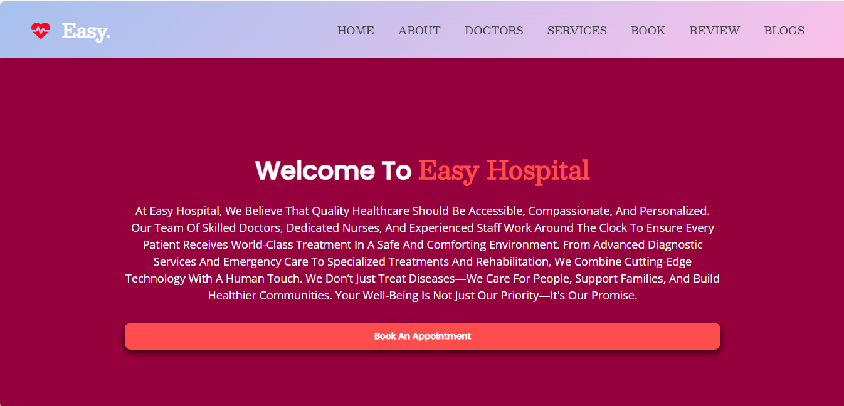

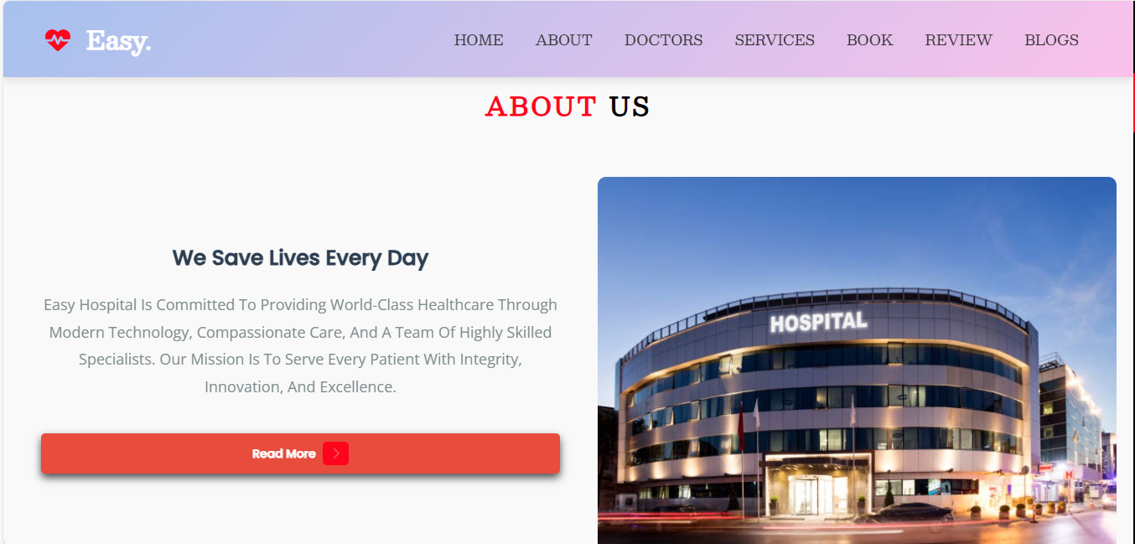

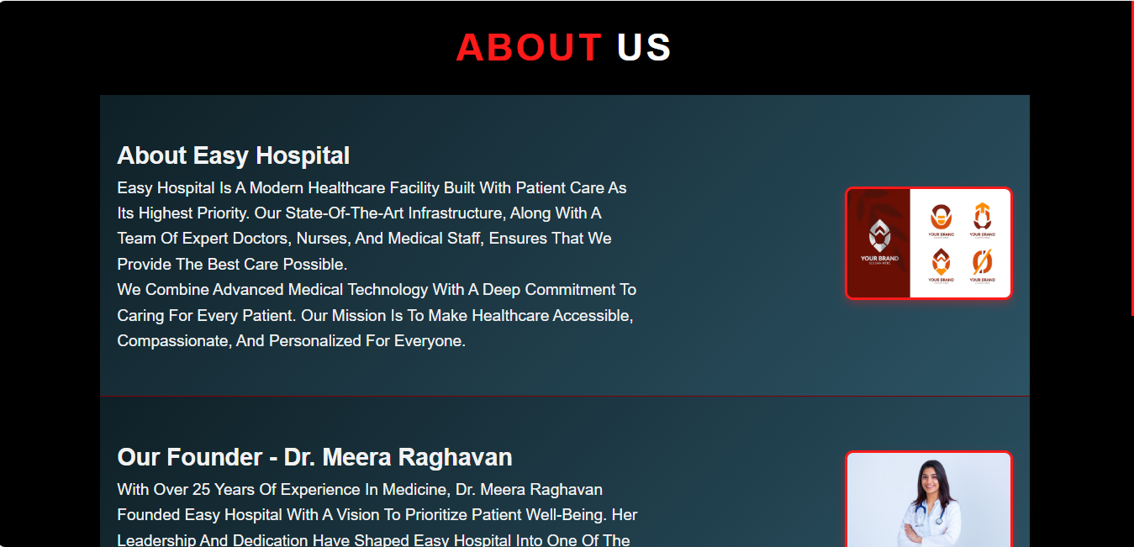



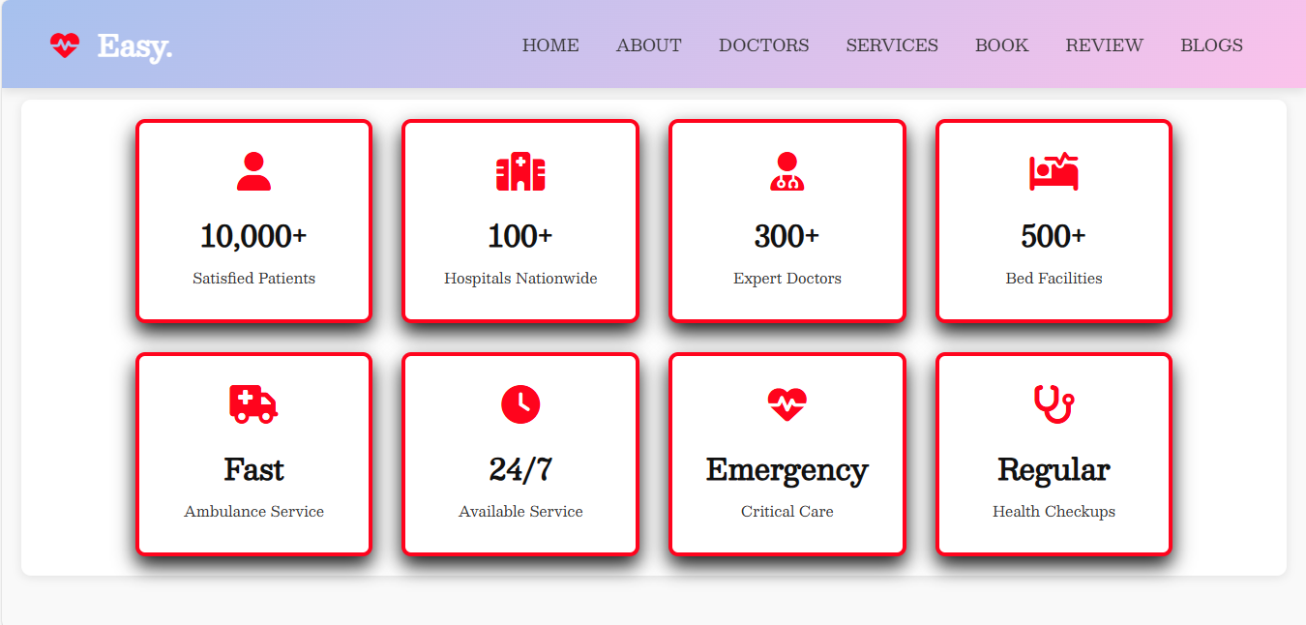

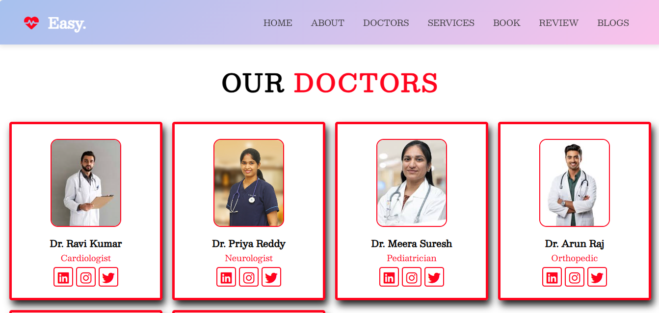

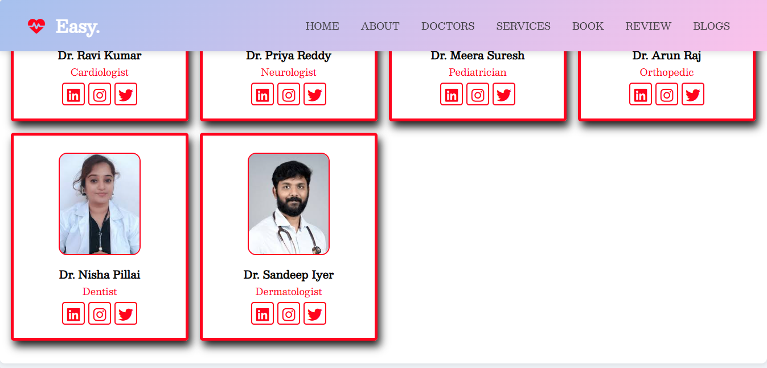

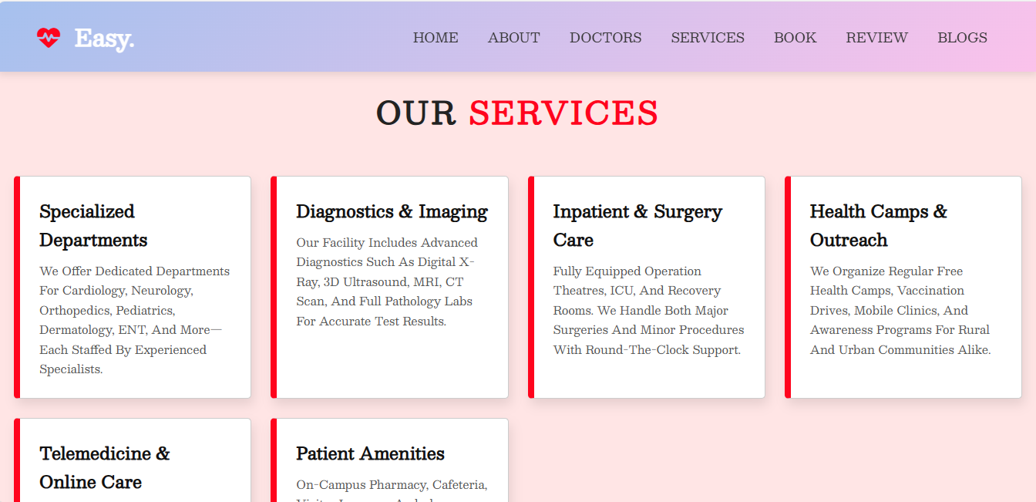

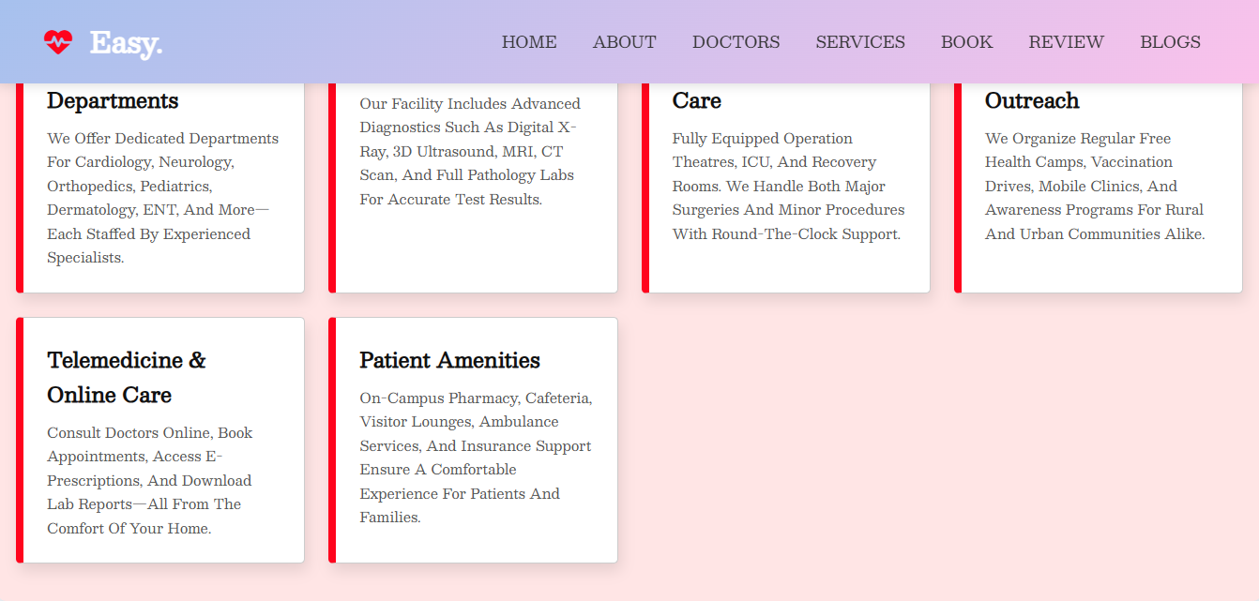

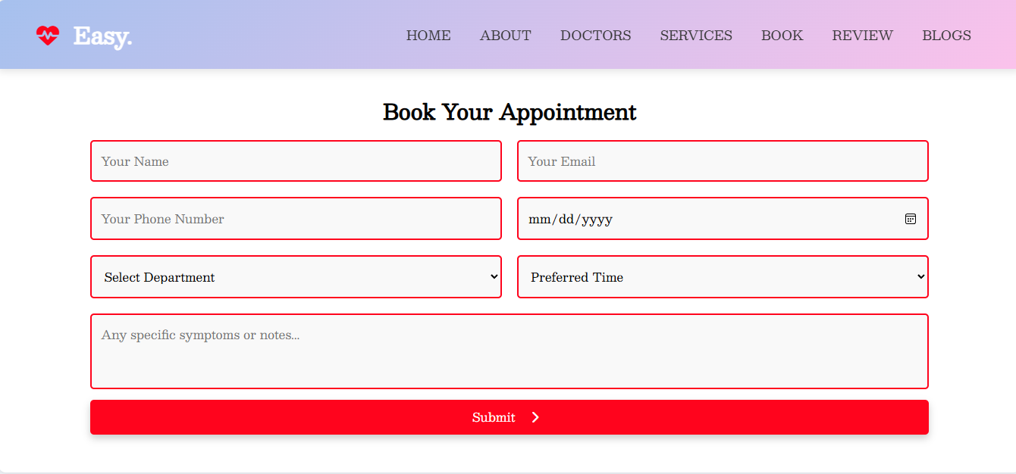

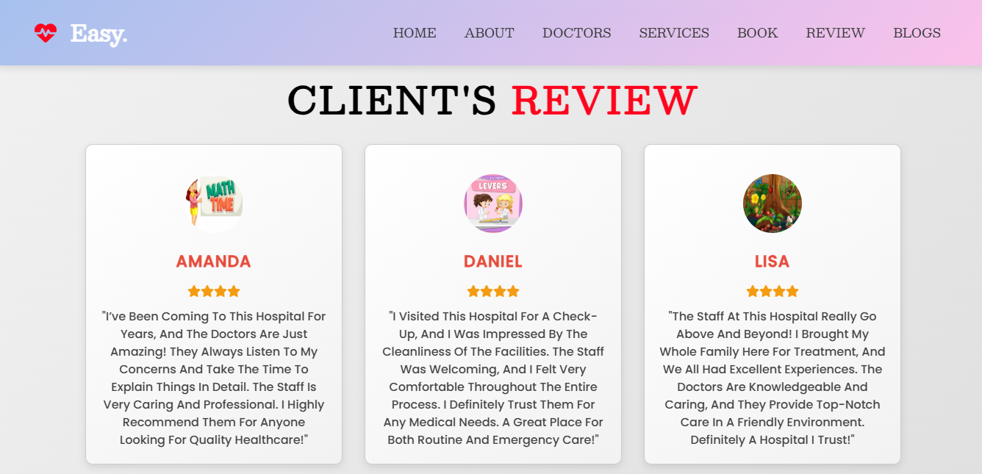

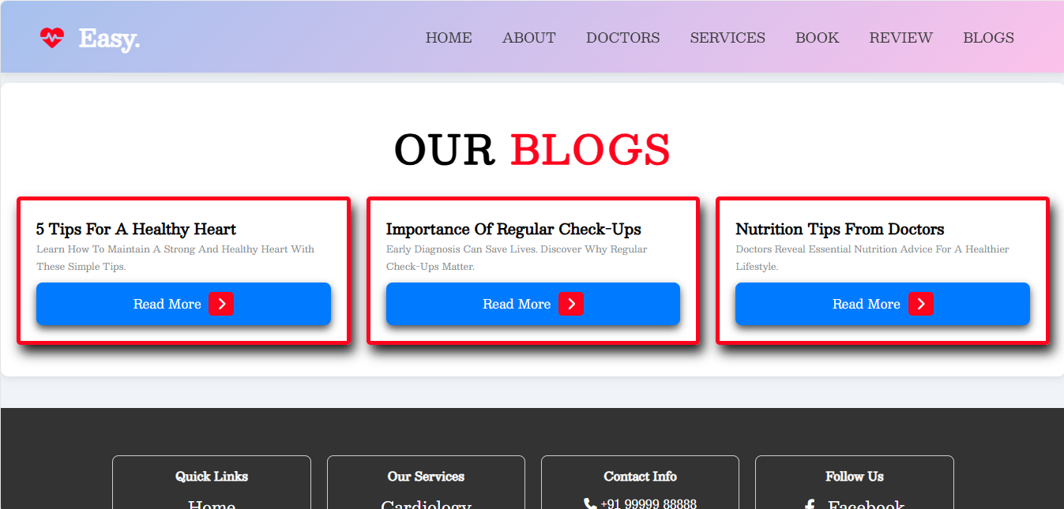

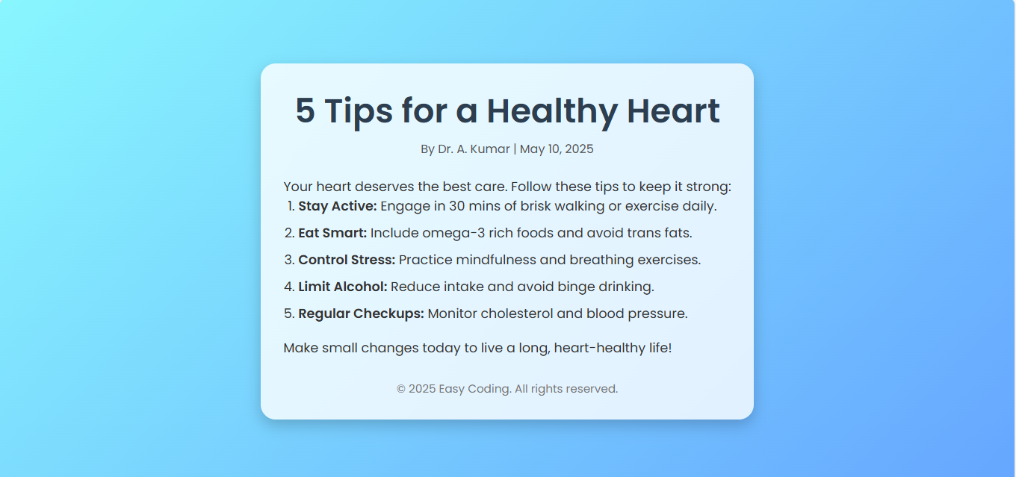

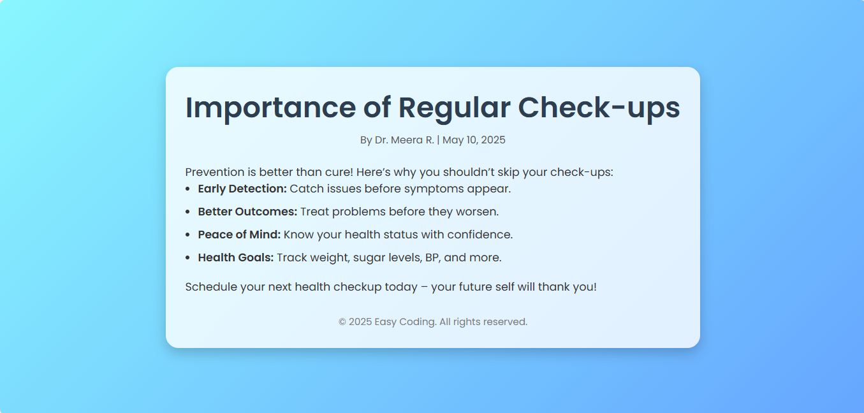

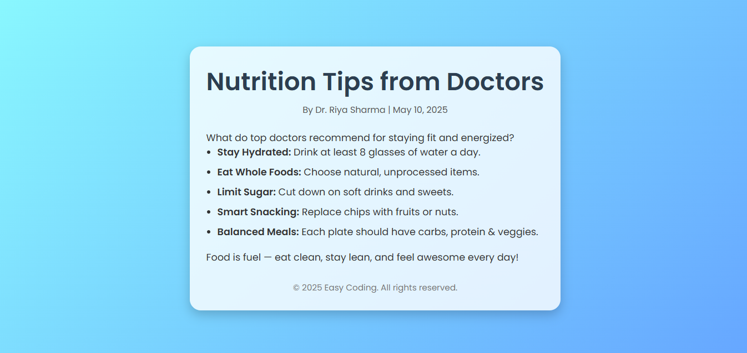

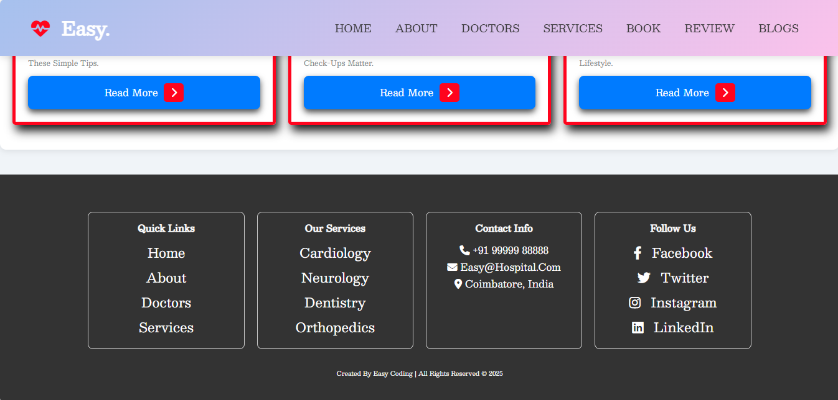

# Firebase Screenshot

